RESEARCHES ON SHOOTING SYSTEM

We can use electromagnet systems with a spring for shooting since it is easy to control by just controlling a switch.

We can buy a module fort his purpose or we can design and build by ourselves because of the constraint of our budget.

The links for the modules are listed below.

1. <https://www.banggood.com/DC-12V-0_4N-Push-Pull-Open-Frame-Solenoid-Electric-Magnet-Holding-p-936843.html?rmmds=detail-left-hotproducts__1&cur_warehouse=CN>
2. <https://www.banggood.com/DC-12V-5N10mm-Push-Pull-Open-Frame-Mini-Valve-Solenoid-Actuator-Electromagnet-p-1097540.html?gmcCountry=TR&currency=TRY&createTmp=1&utm_source=googleshopping&utm_medium=cpc_ods&utm_content=heath&utm_campaign=usc-ods-tr&gclid=EAIaIQobChMIo5b0j5DM3gIV0YeyCh3GaQoaEAYYASABEgIIKfD_BwE&cur_warehouse=CN>
3. <https://www.banggood.com/12V-500mA-10mm-Electromagnet-Solenoid-Actuator-p-1183975.html?rmmds=detail-left-hotproducts__2&cur_warehouse=CN>
4. <https://www.direnc.net/small-push-pull-solenoid-adafruit?lang=tr&h=00c16ac5&gclid=EAIaIQobChMI9pPB6JfM3gIVGeWaCh1rpwPKEAQYASABEgJrjPD_BwE>

We should choose a module having both push and pull feature.

The linear solenoid works on the same basic principal as the electromechanical relay seen in the previous tutorial and just like relays, they can also be switched and controlled using transistors or MOSFET’s. A “Linear Solenoid” is an electromagnetic device that converts electrical energy into a mechanical pushing or pulling force or motion.

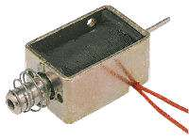

**Linear Solenoid**

Linear solenoid’s basically consist of an electrical coil wound around a cylindrical tube with a ferro-magnetic actuator or “plunger” that is free to move or slide “IN” and “OUT” of the coils body. Solenoids can be used to electrically open doors and latches, open or close valves, move and operate robotic limbs and mechanisms, and even actuate electrical switches just by energising its coil.

*Solenoids* are available in a variety of formats with the more common types being the *linear solenoid* also known as the linear electromechanical actuator, (LEMA) and the *rotary solenoid*.

Both types of solenoid, linear and rotational are available as either a holding (continuously energised) or as a latching type (ON-OFF pulse) with the latching types being used in either energised or power-off applications. Linear solenoids can also be designed for proportional motion control were the plunger position is proportional to the power input.

When electrical current flows through a conductor it generates a magnetic field, and the direction of this magnetic field with regards to its North and South Poles is determined by the direction of the current flow within the wire. This coil of wire becomes an “**Electromagnet**” with its own north and south poles exactly the same as that for a permanent type magnet.

The strength of this magnetic field can be increased or decreased by either controlling the amount of current flowing through the coil or by changing the number of turns or loops that the coil has. An example of an “Electromagnet” is given below.

**Magnetic Field produced by a Coil**

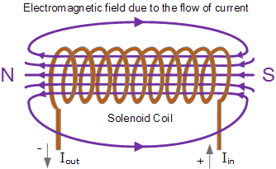

When an electrical current is passed through the coils windings, it behaves like an electromagnet and the plunger, which is located inside the coil, is attracted towards the centre of the coil by the magnetic flux setup within the coils body, which in turn compresses a small spring attached to one end of the plunger. The force and speed of the plungers movement is determined by the strength of the magnetic flux generated within the coil.

When the supply current is turned “OFF” (de-energised) the electromagnetic field generated previously by the coil collapses and the energy stored in the compressed spring forces the plunger back out to its original rest position. This back and forth movement of the plunger is known as the solenoids “Stroke”, in other words the maximum distance the plunger can travel in either an “IN” or an “OUT” direction, for example, 0 – 30mm.

Linear Solenoid Construction

This type of solenoid is generally called a **Linear Solenoid** due to the linear directional movement and action of the plunger. Linear solenoids are available in two basic configurations called a “Pull-type” as it pulls the connected load towards itself when energised, and the “Push-type” that act in the opposite direction pushing it away from itself when energised. Both push and pull types are generally constructed the same with the difference being in the location of the return spring and design of the plunger.

**Pull-type Linear Solenoid Construction**

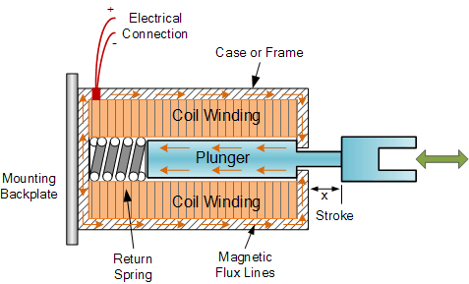

Linear solenoids are useful in many applications that require an open or closed (in or out) type motion such as electronically activated door locks, pneumatic or hydraulic control valves, robotics, automotive engine management, irrigation valves to water the garden and even the “Ding-Dong” door bell has one. They are available as open frame, closed frame or sealed tubular types.

**Rotary Solenoids**

Most electromagnetic solenoids are linear devices producing a linear back and forth force or motion. However, rotational solenoids are also available which produce an angular or rotary motion from a neutral position in either clockwise, anti-clockwise or in both directions (bi-directional).

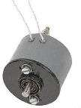

**Rotary Solenoid**

Rotary solenoids can be used to replace small DC motors or stepper motors were the angular movement is very small with the angle of rotation being the angle moved from the start to the end position.

Commonly available rotary solenoids have movements of 25, 35, 45, 60 and 90o as well as multiple movements to and from a certain angle such as a 2-position self restoring or return to zero rotation, for example 0-to-90-to-0o, 3-position self restoring, for example 0o to +45o or 0o to -45o as well as 2-position latching.

Rotary solenoids produce a rotational movement when either energised, de-energised, or a change in the polarity of an electromagnetic field alters the position of a permanent magnet rotor. Their construction consists of an electrical coil wound around a steel frame with a magnetic disk connected to an output shaft positioned above the coil.

When the coil is energised the electromagnetic field generates multiple north and south poles which repel the adjacent permanent magnetic poles of the disk causing it to rotate at an angle determined by the mechanical construction of the rotary solenoid.

Rotary solenoids are used in vending or gaming machines, valve control, camera shutter with special high speed, low power or variable positioning solenoids with high force or torque are available such as those used in dot matrix printers, typewriters, automatic machines or automotive applications etc.

**Solenoid Switching**

Generally solenoids either linear or rotary operate with the application of a DC voltage, but they can also be used with AC sinusoidal voltages by using full wave bridge rectifiers to rectify the supply which then can be used to switch the DC solenoid. Small DC type solenoids can be easily controlled using Transistor or MOSFET switches and are ideal for use in robotic applications.

However, as we saw previously with electromechanical relays, linear solenoids are “inductive” devices so some form of electrical protection is required across the solenoid coil to prevent high back emf voltages from damaging the semiconductor switching device. In this case the standard “Flywheel Diode” is used, but you could equally use a zener diode or small value varistor.

**Switching Solenoids using a Transistor**

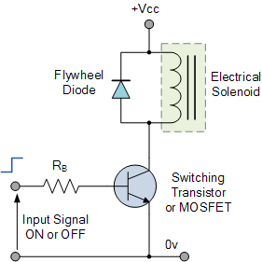

**Reducing Energy Consumption**

One of the main disadvantages of solenoids and especially the **linear solenoid** is that they are “inductive devices” made from coils of wire. This means that the solenoid coil converts some of the electrical energy used to operate them into “HEAT” due to the resistance of the wire.

In other words when connected for long periods of time to an electrical supply they get hot!, and the longer the time that the power is applied to a solenoid coil, the hotter the coil will become. Also as the coil heats up, its electrical resistance also changes allowing more current to flow increasing its temperature.

With a continuous voltage input applied to the coil, the solenoids coil does not have the opportunity to cool down because the input power is always on. In order to reduce this self generated heating effect it is necessary to reduce either the amount of time the coil is energised or reduce the amount of current flowing through it.

One method of consuming less current is to apply a suitable high enough voltage to the solenoid coil so as to provide the necessary electromagnetic field to operate and seat the plunger but then once activated to reduce the coils supply voltage to a level sufficient to maintain the plunger in its seated or latched position. One way of achieving this is to connect a suitable “holding” resistor in series with the solenoids coil, for example:

**Reducing Solenoid Energy Consumption**

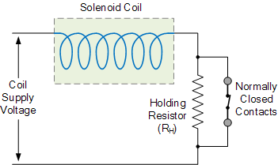

Here, the switch contacts are closed shorting out the resistance and passing the full supply current directly to the solenoid coils windings. Once energised the contacts which can be mechanically connected to the solenoids plunger action open connecting the holding resistor, RH in series with the solenoids coil. This effectively connects the resistor in series with the coil.

By using this method, the solenoid can be connected to its voltage supply indefinitely (continuous duty cycle) as the power consumed by the coil and the heat generated is greatly reduced, which can be up to 85 to 90% using a suitable power resistor. However, the power consumed by the resistor will also generate a certain amount of heat, I2R (Ohm’s Law) and this also needs to be taken into account.

**Solenoid Duty Cycle**

Another more practical way of reducing the heat generated by the solenoids coil is to use an “intermittent duty cycle”. An intermittent duty cycle means that the coil is repeatedly switched “ON” and “OFF” at a suitable frequency so as to activate the plunger mechanism but not allow it to de-energise during the OFF period of the waveform. Intermittent duty cycle switching is a very effective way to reduce the total power consumed by the coil.

The Duty Cycle (%ED) of a solenoid is the portion of the “ON” time that a solenoid is energised and is the ratio of the “ON” time to the total “ON” and “OFF” time for one complete cycle of operation. In other words, the cycle time equals the switched-ON time plus the switched-OFF time. Duty cycle is expressed as a percentage, for example:

intermittent duty cycle

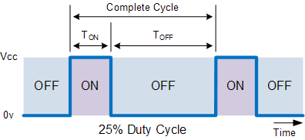

Then if a solenoid is switched “ON” or energised for 30 seconds and then switched “OFF” for 90 seconds before being re-energised again, one complete cycle, the total “ON/OFF” cycle time would be 120 seconds, (30+90) so the solenoids duty cycle would be calculated as 30/120 secs or 25%. This means that you can determine the solenoids maximum switch-ON time if you know the values of duty cycle and switch-OFF time.

For example, the switch-OFF time equals 15 secs, duty cycle equals 40%, therefore switch-ON time equals 10 secs. A solenoid with a rated Duty Cycle of 100% means that it has a continuous voltage rating and can therefore be left “ON” or continuously energised without overheating or damage.

In this tutorial about solenoids, we have looked at both the **Linear Solenoid** and the **Rotary Solenoid** as an electromechanical actuator that can be used as an output device to control a physical process. In the next tutorial we will continue our look at output devices called **Actuators**, and one that converts a electrical signal into a corresponding rotational movement again using electromagnetism. The type of output device we will look at in the next tutorial is the DC Motor.

<https://www.electronics-tutorials.ws/io/io_6.html>